**EXPERIMENT 3- Installation of QEMU & KVM on UBUNTU in VMware Workstation.**

**Step 1:**Open the ubuntu in your VM Ware Workstation, and then open the terminal in ubuntu.

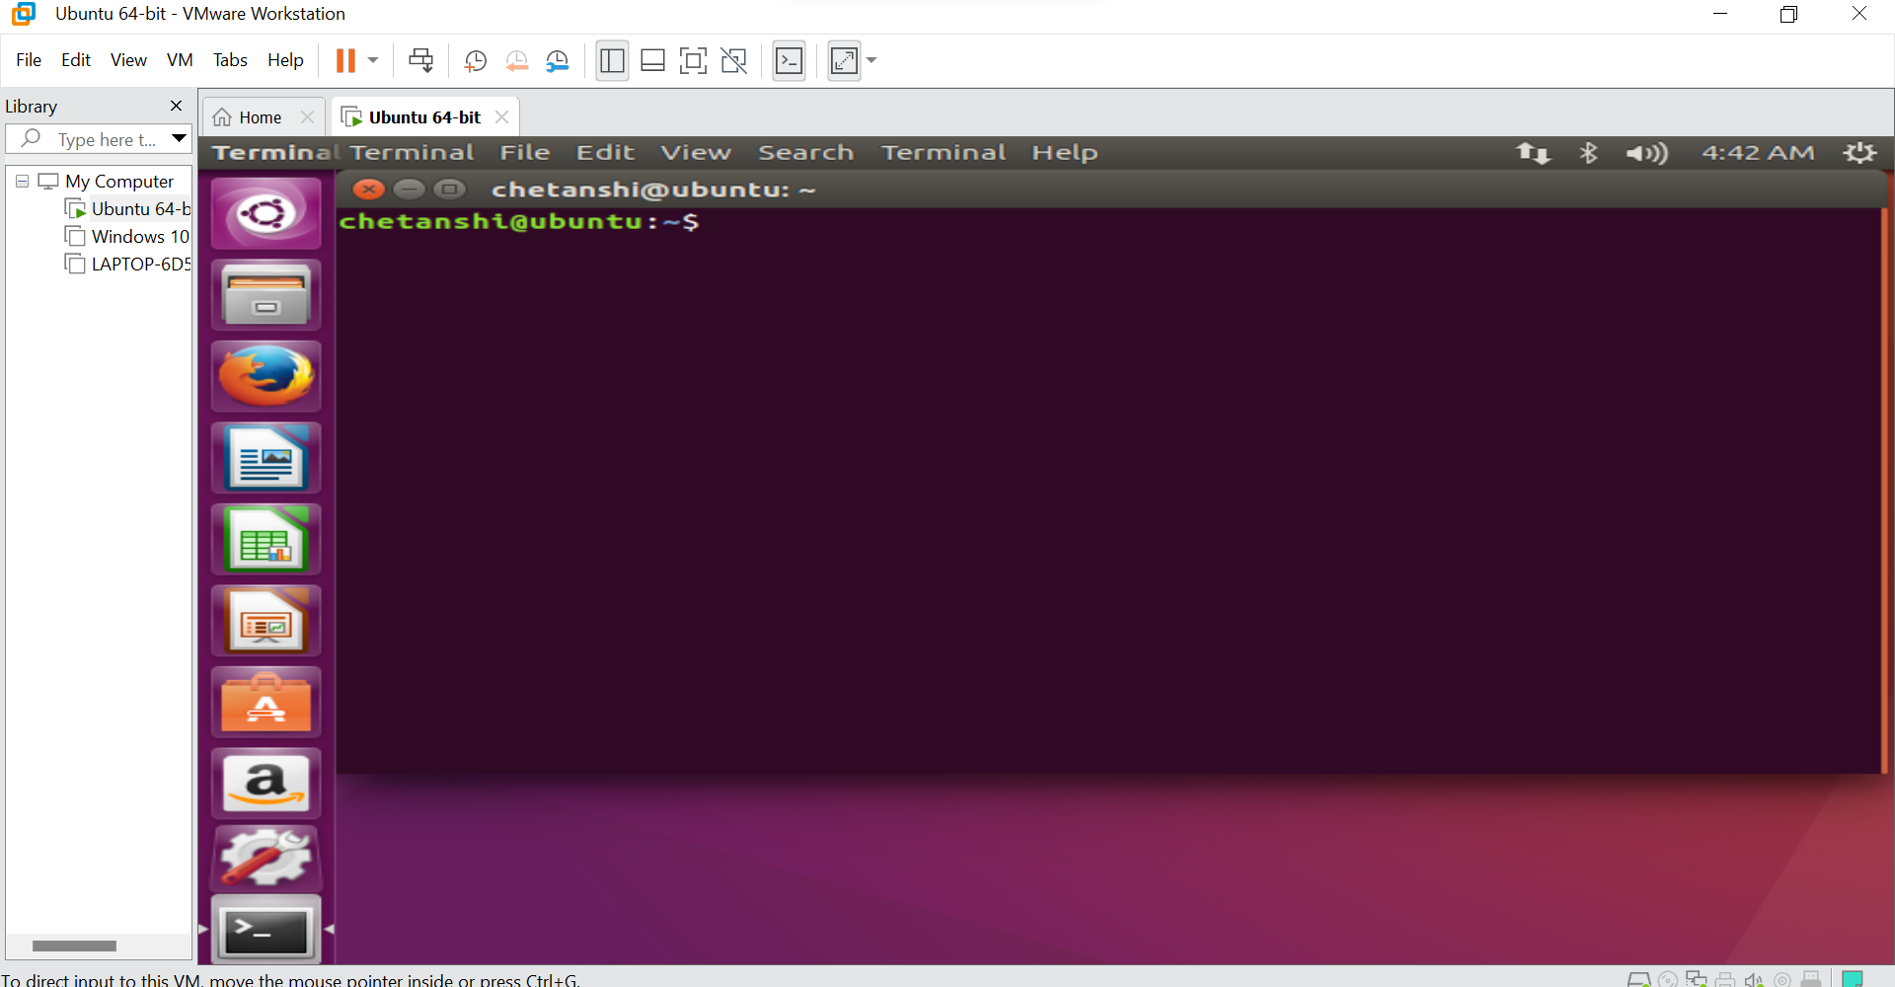

**Step 2:** Type the command- “egrep -c ‘(vmx|svm)’ /proc/cpuinfo”.

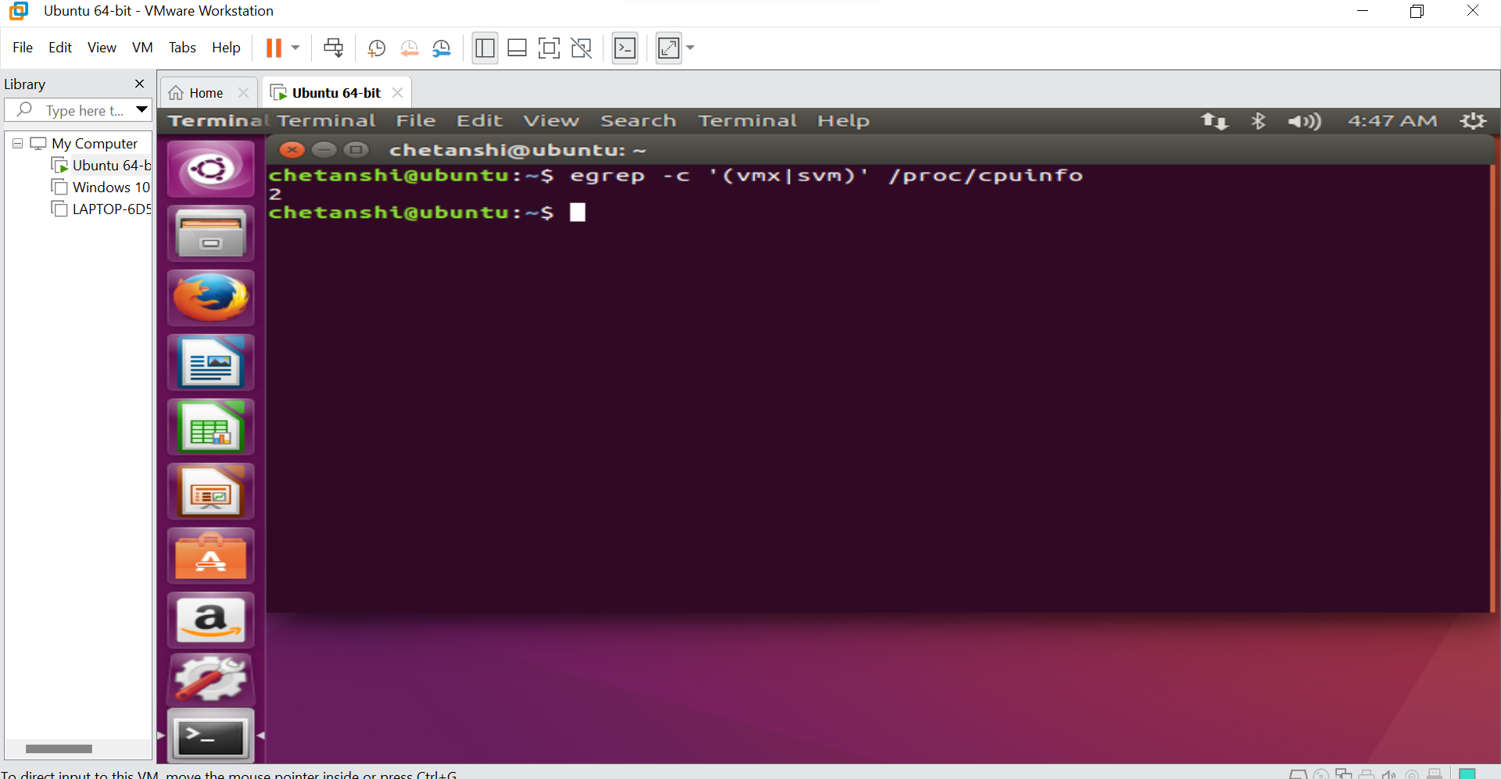

**Step 3:** The command will return you a positive integer if not then go to -

“edit the virtual machine - >hardware -> Processor-> check the Intel-VT check box”.

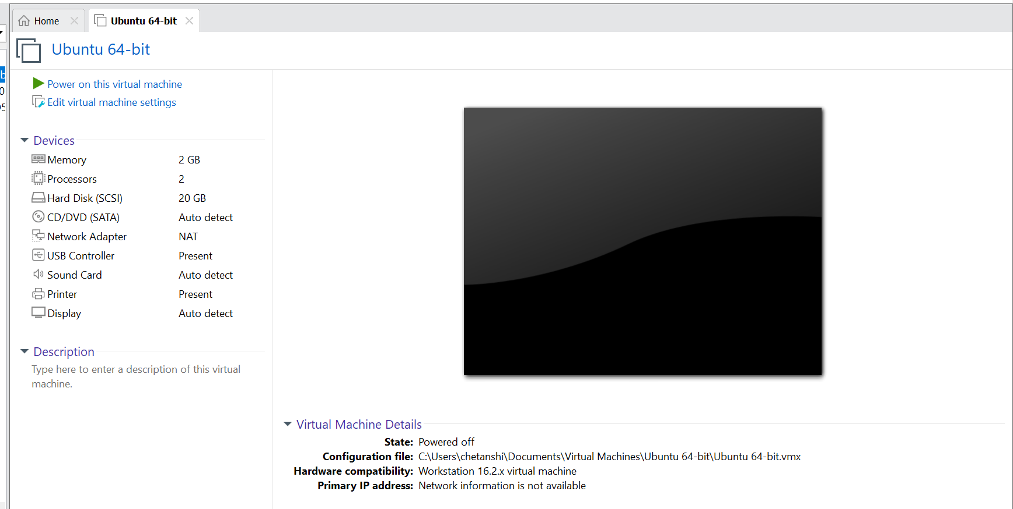

**Step 4:** Type the command- “sudo kvm-ok”, then enter the password.

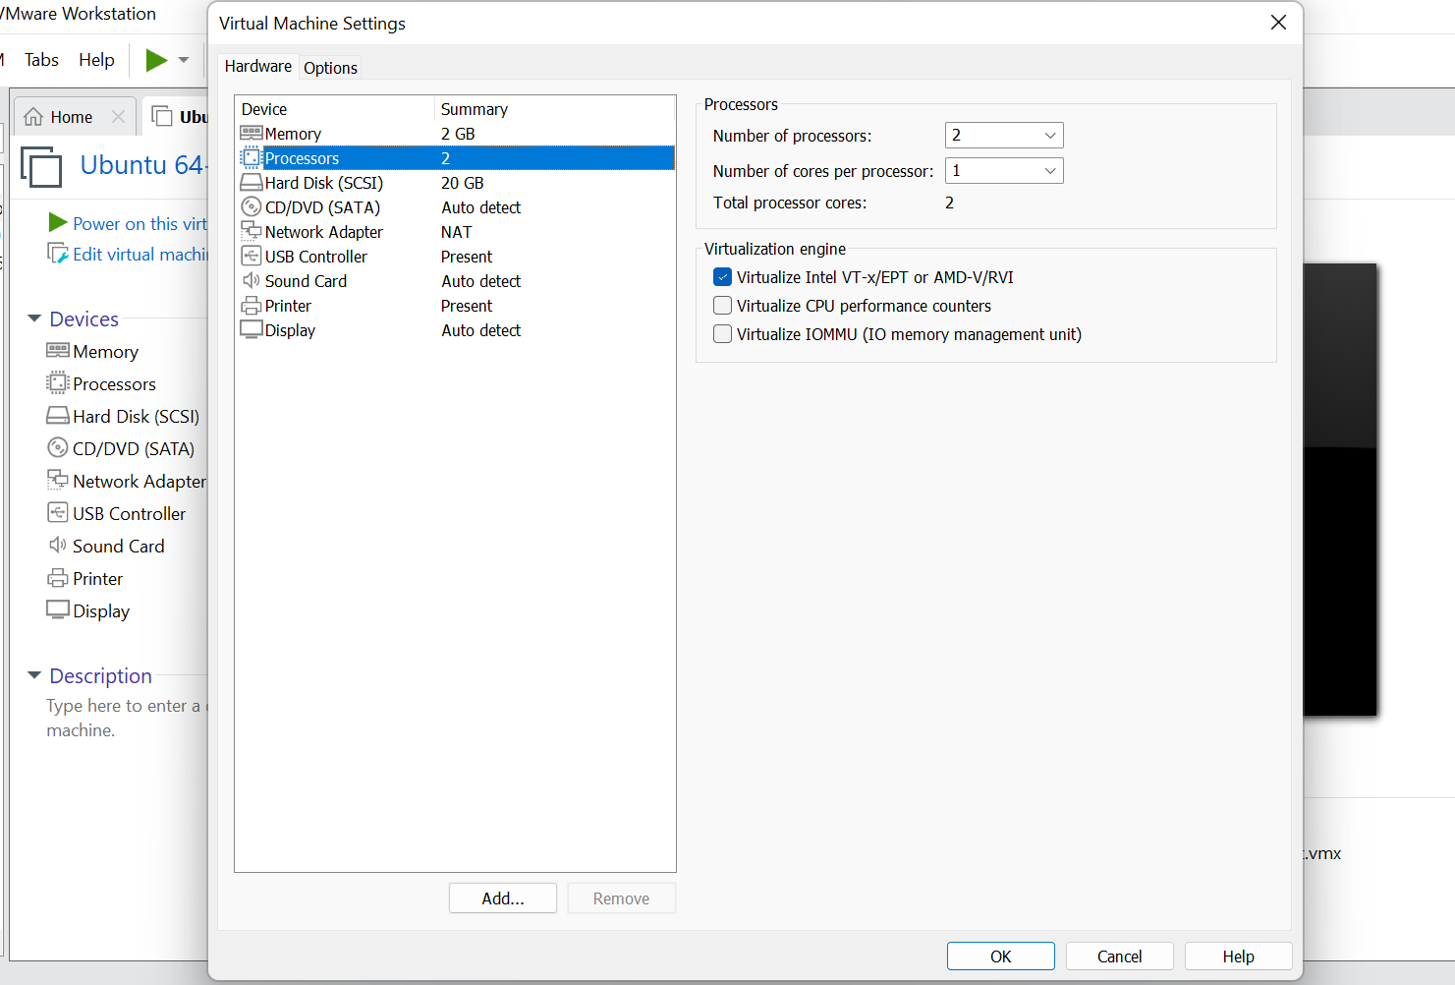

**Step 5:** Then type -“sudo apt install cpu-checker”.

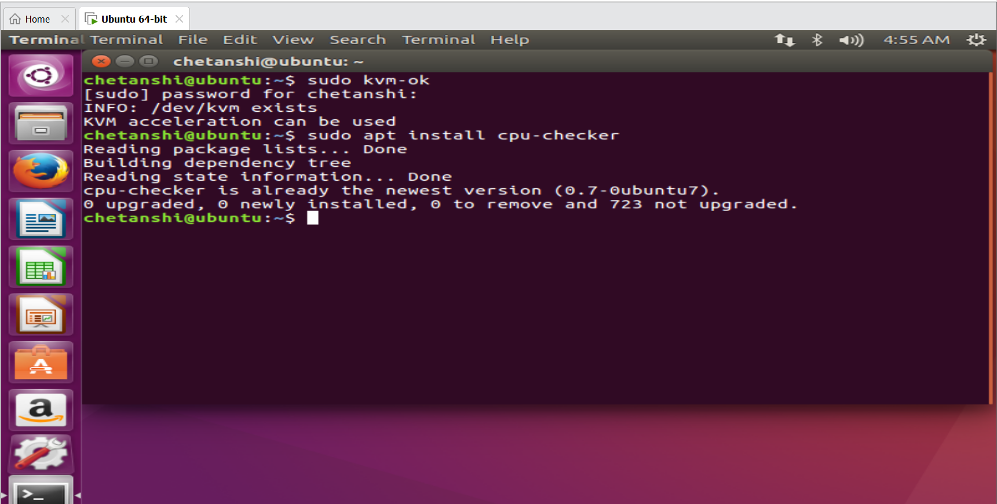

**Step 6:** Again type “sudo kvm-ok”.

The command is to check whether the kvm acceleration can be used or not.

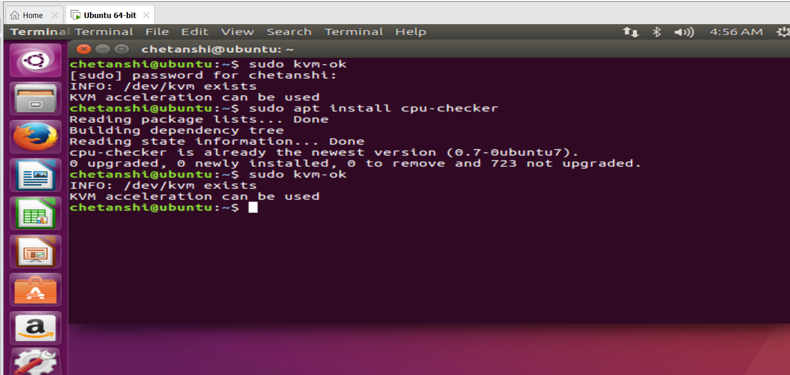

**Step 7:** Then download all the packages which are required for using the virt-manager. To download all the files type

“sudo apt install -y qemu qemu-kvm libvirt-daemon libvirt-clients bridge-utils virt-manager”. You can use “libvirt-bin” instead of “libvirt-daemon”

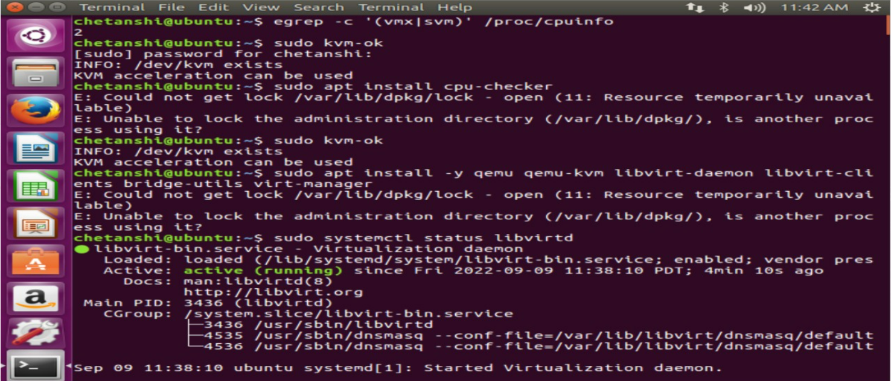

**Step 8:** Then type “sudo systemctl status libvirtd”.

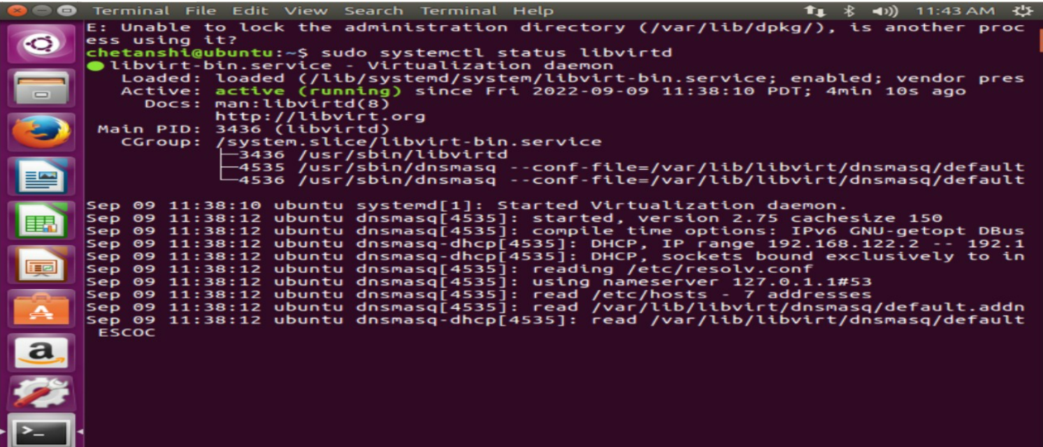

**Step 9**: Then type “sudo systemctl enable --now libvirtd”

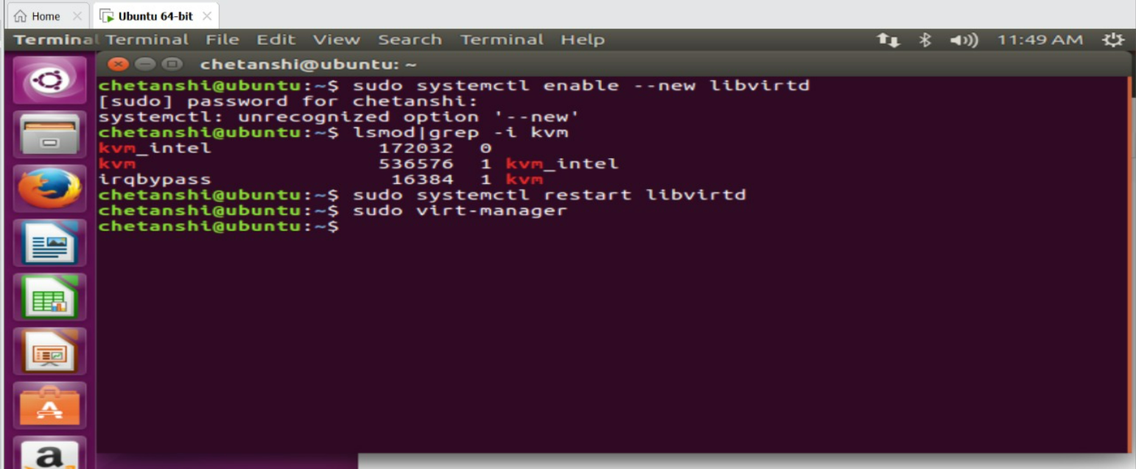

**Step 10:** Then type “lsmod|grep -ikvm”



**Step 11:** Then restart the libvirtd by using the command

“sudo systemctl restart libvirtd”.



**Step 12:** for opening the virtual machine manager type the command

“sudo virt-manager”.

